Jose Martinez, Lab Assignment #5, March 20th/2025

Objectives:
Understand the layout of the bread board.
Identify the port number.
Create a C++ project around the C++ sample code provided.
Comment the C++ code. All program code should be commented.
Perform several specific program modifications.
Post on the Network Module Usage discussion board.
Submit a "high quality" deliverable which includes comments and screen shots to illustrate your complete experience with the lab activity.

- Create a new C++ "Win32 Console" Application called TDBTraffic.
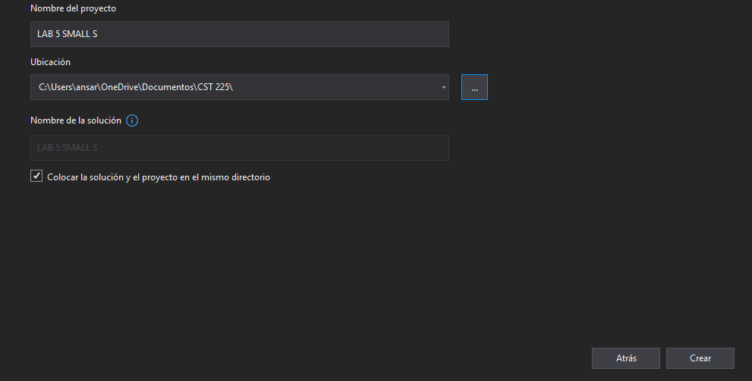

You should choose the Application Settings menu item shown along the left side of the screen. This will provide access to the settings that should be modified
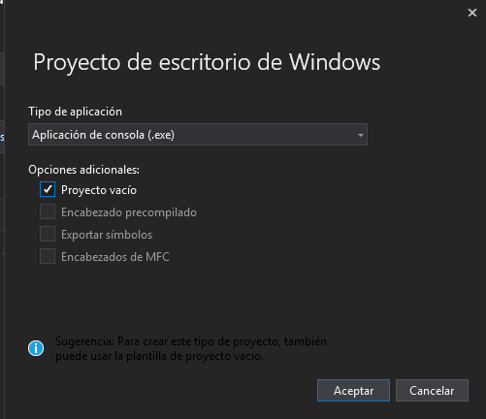

You need to make sure that "Console application" is selected and a check appears in the box next to Empty Project. We want an empty project. When you are done, select the Finish button to allow the Visual Studio to create the project.
When that is complete, you will need to select "Add new item" from the project pull down menu.
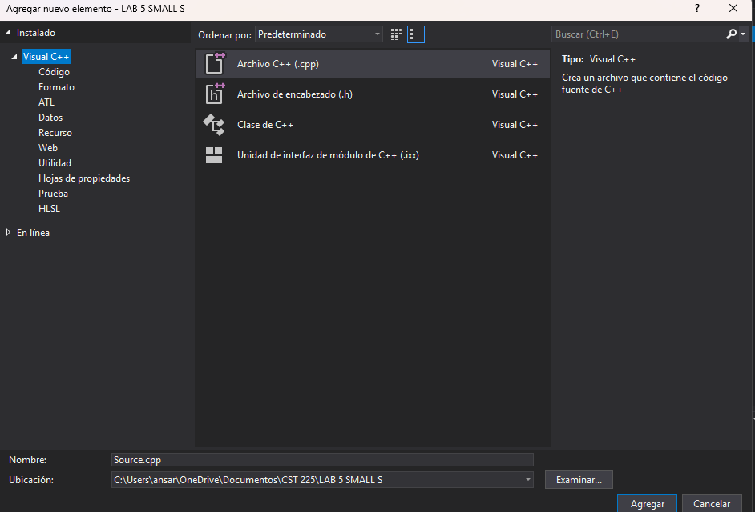
Select Visual C++ in the category field and C++ File from the Templates area, and supply the name TDBTraffic in the Name field. When you press "Add" button, a blank source code file will be visible
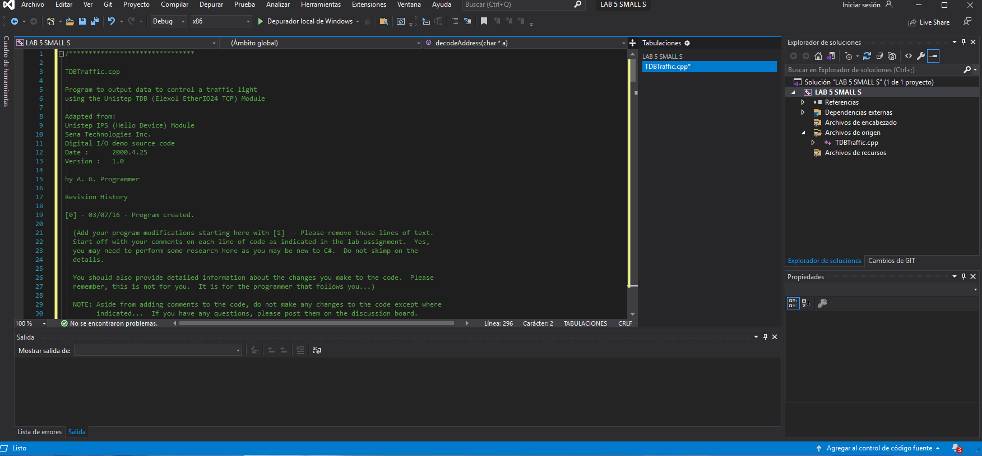
Additional Process to add Windows Sockets Library to your Solution
- 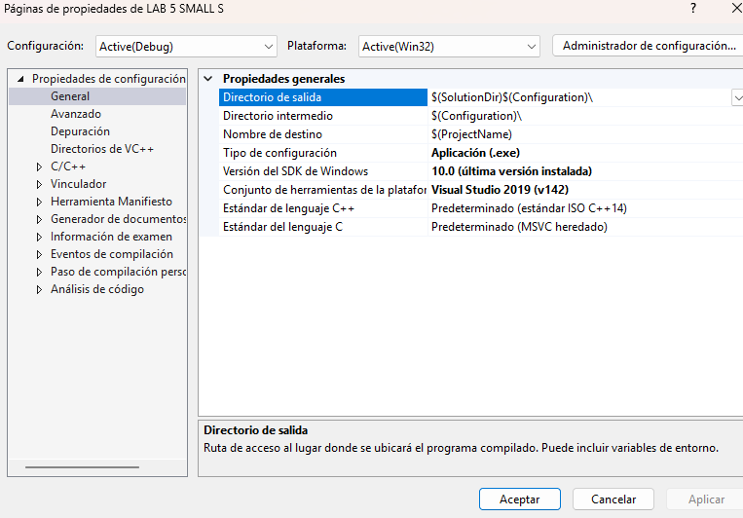project property page, Windows Sockets 1.1 is WSock32.lib

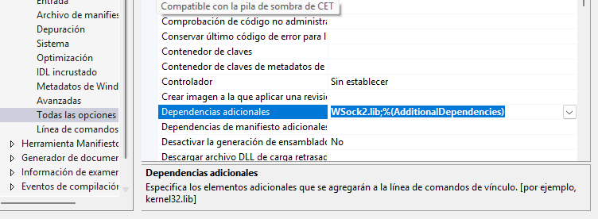
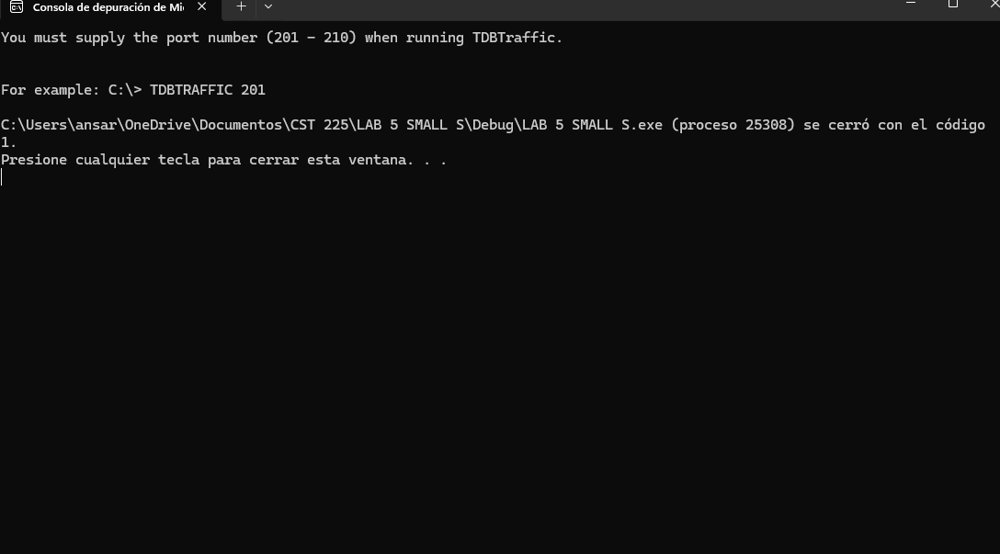my program run successfully the first time
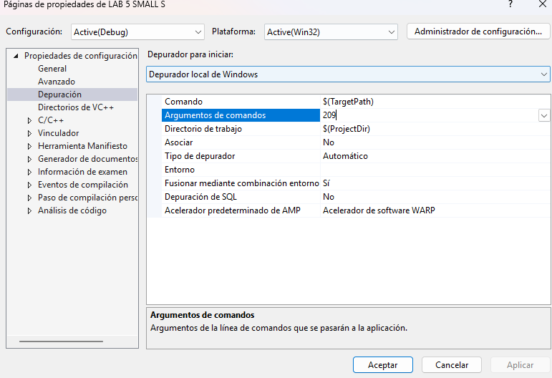I chose port 209
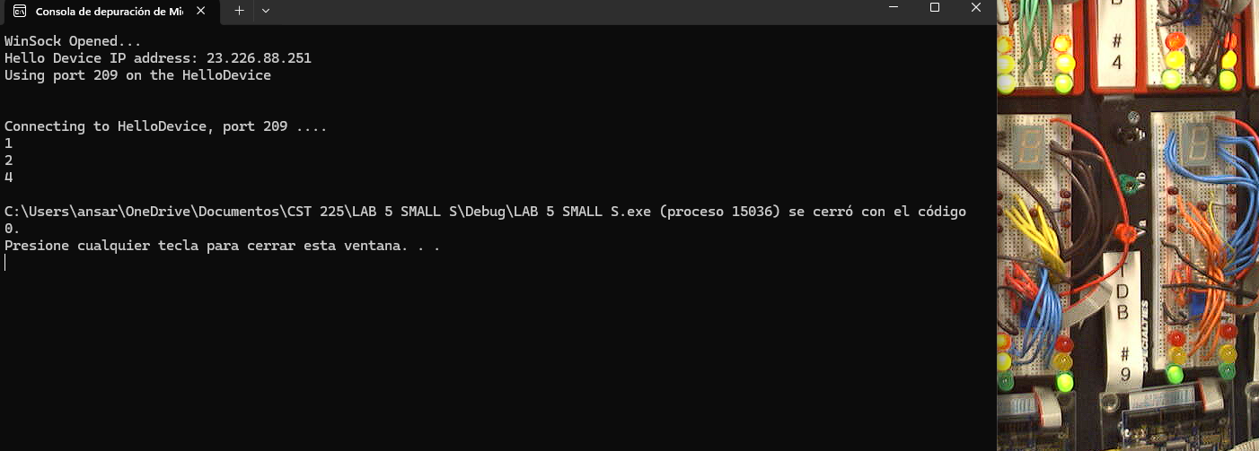It ran successfully
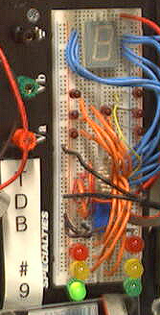
Program Modification - 1
Modify the sample source code as indicated:
- You should fully document each line of the source code.
- You should update the program revision history as indicated in the sample provided in the header.
- Make the LEDs light up in the order specified in the Traffic Light Identification Table - 1 shown below and then turn them off.
- Each of the LEDs should stay on for the time specified in the table.
- The program should output additional text messages indicating which of the lights are being turned on.
- At the end of the program execution, all of the LEDs should be off.
- Screen shots of the running code and the LED output from your selected module must be included in your submission.
- 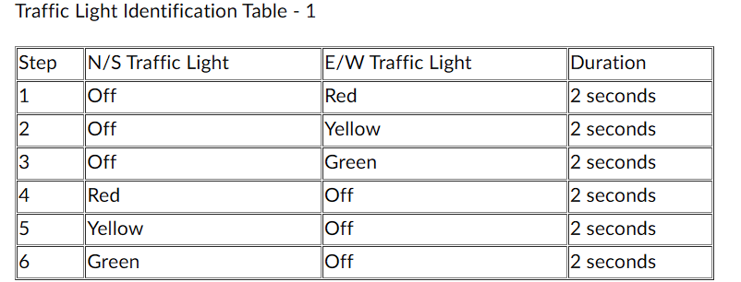

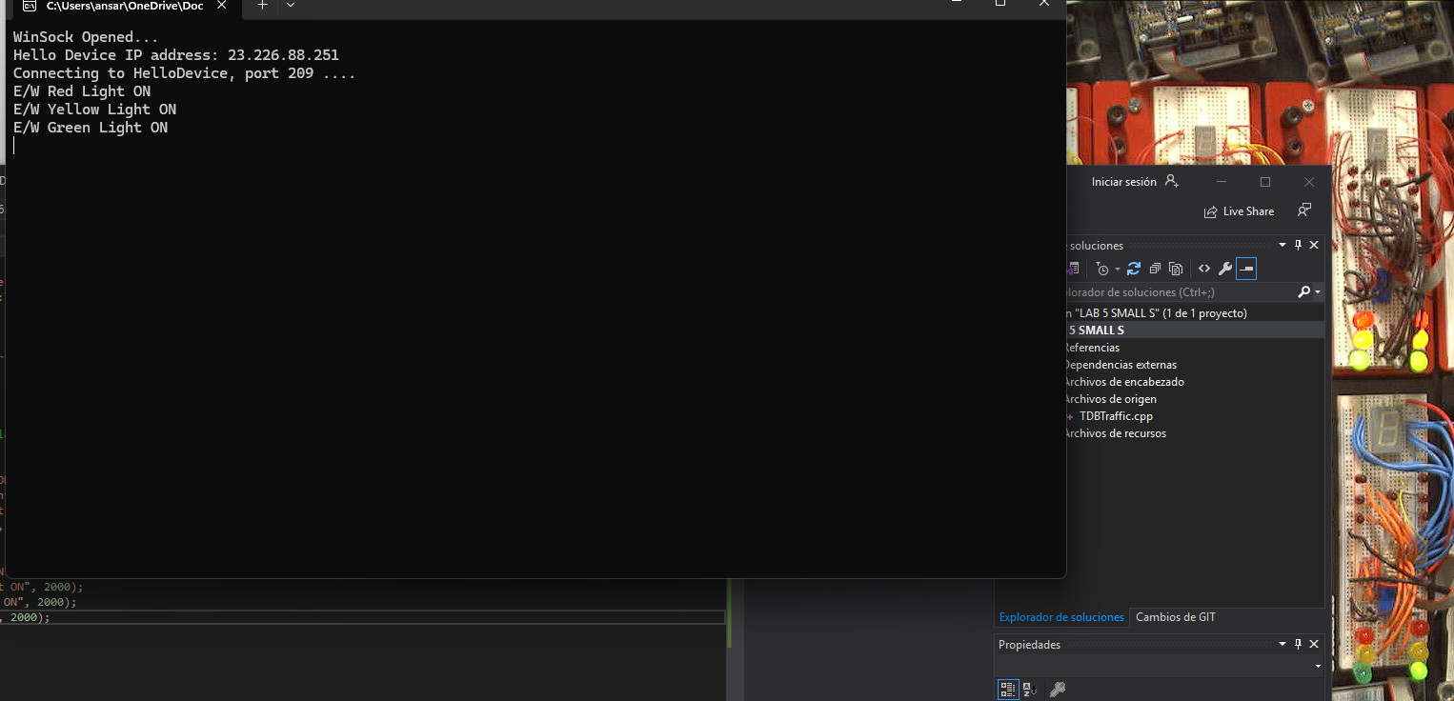
My program ran successfully, and the lights in the order.

Program Modification - 2
Modify the sample source code as indicated:

You should fully document each line of the source code.
You should update the program revision history.
Code the lights to correspond with Regular Traffic Operation - 2 shown below. Repeat the process for a total of THREE iterations.
Code the lights to correspond with Overnight Flashing Operation - 2 shown below. Repeat the process for a total of TWO iterations.
The LEDs should stay on for the durations indicated in each of the tables.
The program should also contain output text messages indicating which of the lights are being turned on.
At the end of the program execution, all of the LEDs should be off.
A screen shot of the running code and the LED output from your selected module must be included in your submission.
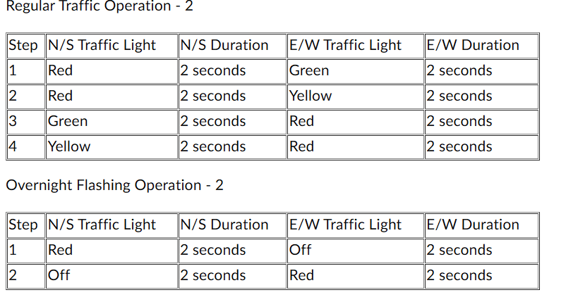
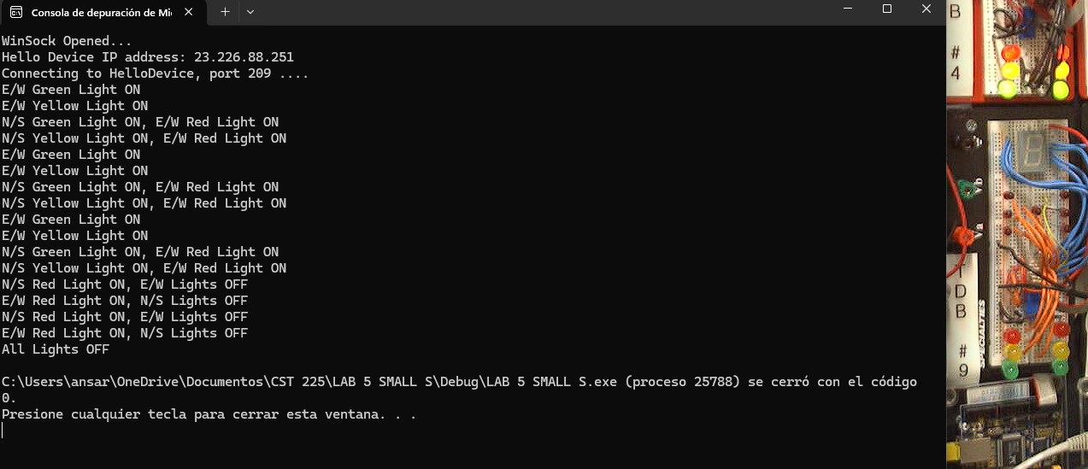
Lights run successfully , I had problems with the values in first instance.
WireShark
For additional useful experience, download, install WireShark.

Run WireShark and capture traffic while your program is running . If necessary, re-run some of the experiments and see the network data exchange process. If you have questions about installing or using Wireshark, please post them on the discussion board.
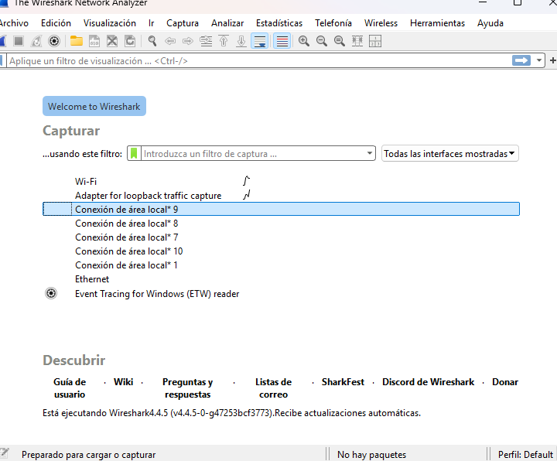First look at WIRESHARK
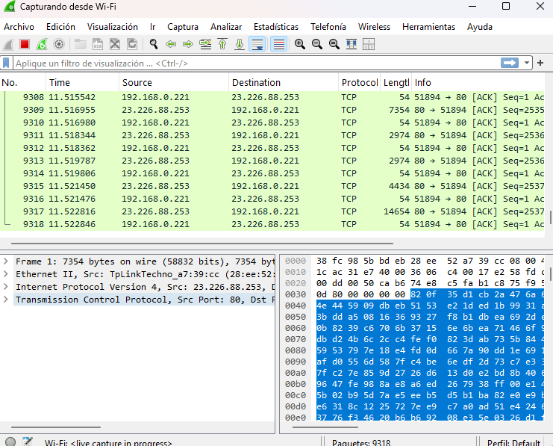
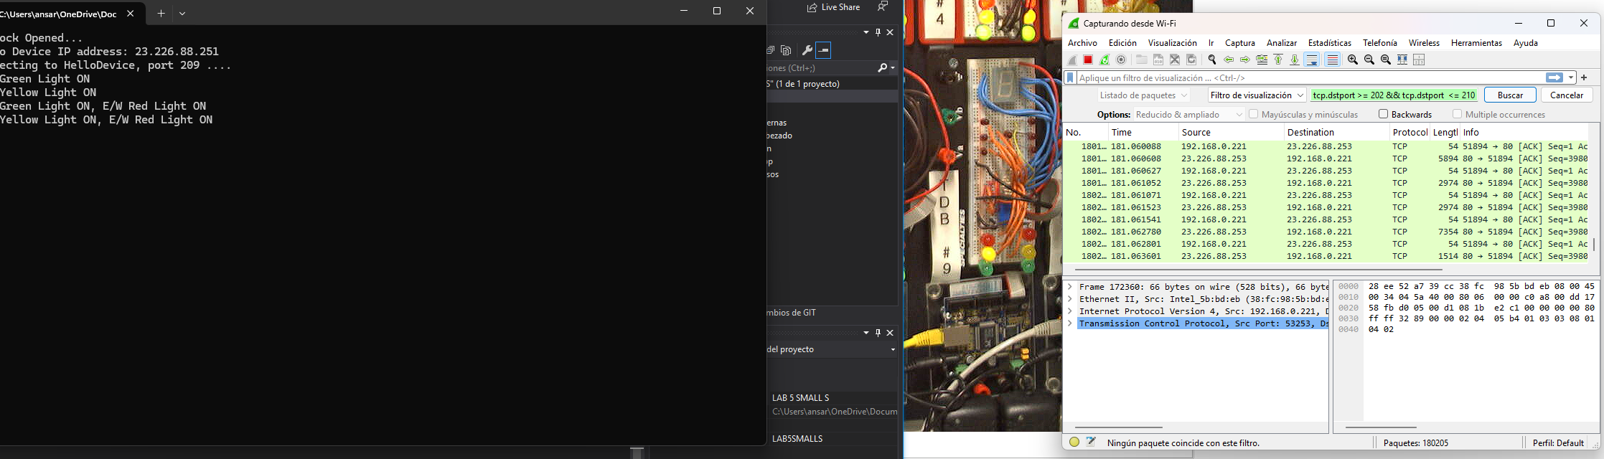
In this screenshot I ran my program and Wireshark at the same time.
*It’s amazing how Wireshark detects the port number.

List of problems: I had many problems with the values of the lights, and the code modifications.

